QWeather - User Guide

QWeather is a weather application for Maemo5. It gives you information, about the weather at your position, through your GPS-location. To see the weather from other cities, you can simply enter an address and hit the GO button. A three-day forecast is also included.

At the start, the App looks for the location (only works good with SIM). If a position was found, the latitude and longitude values get reverse geocoded and the final address is inserted in the white line.

By pressing go, a weather Request with the address is sended.

If the received xml was parsed successfully, the values are inserted in the fields. and graphics are selected.

*Screenshot: Weather at your GPS-location.*

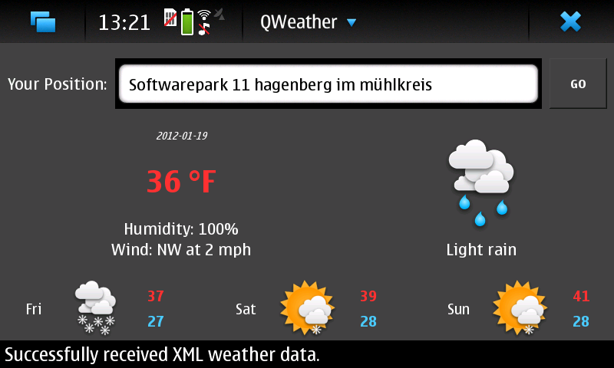

*Screenshot: Weather at the entered address.*

